Faculty of Technology and Engineering
Chandubhai S. Patel Institute of Technology (CSPIT)
Department of Computer Science & Engineering
Date: 6 /8 / 26
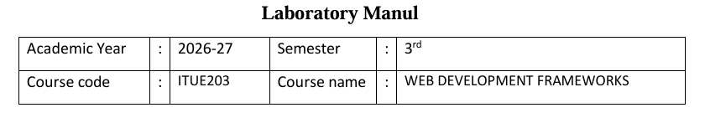
Practical – 4
PROBLEM STATEMENT : Design responsive layouts for Home, About, Registration, Dashboard, and Events pages using CSS Grid and Flexbox. Optional to use CSS
framework such as Bootstrap or Tailwind. Ensure mobile-first responsiveness.
Objective:-
To design responsive and mobile-first layouts for the Home, About, Registration, Dashboard, and Events pages using CSS Grid and Flexbox (or a CSS framework like Bootstrap or Tailwind) to ensure an accessible, user-friendly, and consistent experience across different screen sizes.
Code:
Code of collapsible FAQ:
<section class="faq-section" aria-labelledby="faq-title">
<div class="section-header faq-header">
<div>
<p class="eyebrow">Support</p>
<h2 id="faq-title">Frequently asked questions</h2>
</div>
</div>

<div class="faq-list">
<article class="faq-item active">
<button class="faq-question" type="button" aria-expanded="true">
<span>How do I access my dashboard?</span>
<span class="faq-icon" aria-hidden="true">+</span>
</button>
<div class="faq-answer">
<p>Select your role from the landing page, enter the matching campus ID and password, and you will be redirected to the correct dashboard.</p>
</div>
</article>

<article class="faq-item">
<button class="faq-question" type="button" aria-expanded="false">
<span>What can students do on the portal?</span>
<span class="faq-icon" aria-hidden="true">+</span>
</button>
<div class="faq-answer">
<p>Students can check attendance, review academic results, access assignments, and stay updated with important announcements from the campus.</p>
</div>
</article>

<article class="faq-item">
<button class="faq-question" type="button" aria-expanded="false">
<span>How do faculty members manage courses?</span>
<span class="faq-icon" aria-hidden="true">+</span>
</button>
<div class="faq-answer">
<p>Faculty users can view assigned courses, monitor student participation, update grades, and manage academic records from the faculty dashboard.</p>
</div>
</article>

<article class="faq-item">
<button class="faq-question" type="button" aria-expanded="false">
<span>Who can access the admin panel?</span>
<span class="faq-icon" aria-hidden="true">+</span>
</button>
<div class="faq-answer">
<p>Only authorized administrators can access the admin panel to manage users, announcements, and system-level campus settings.</p>
</div>
</article>

<article class="faq-item">
<button class="faq-question" type="button" aria-expanded="false">
<span>Are the login details demo credentials?</span>
<span class="faq-icon" aria-hidden="true">+</span>
</button>
<div class="faq-answer">
<p>Yes. These examples are intentionally set up for the demo portal, allowing users to test role-based access in a secure sample environment.</p>
</div>
</article>
</div>
</section>
Screenshot of collapsible FAQ:

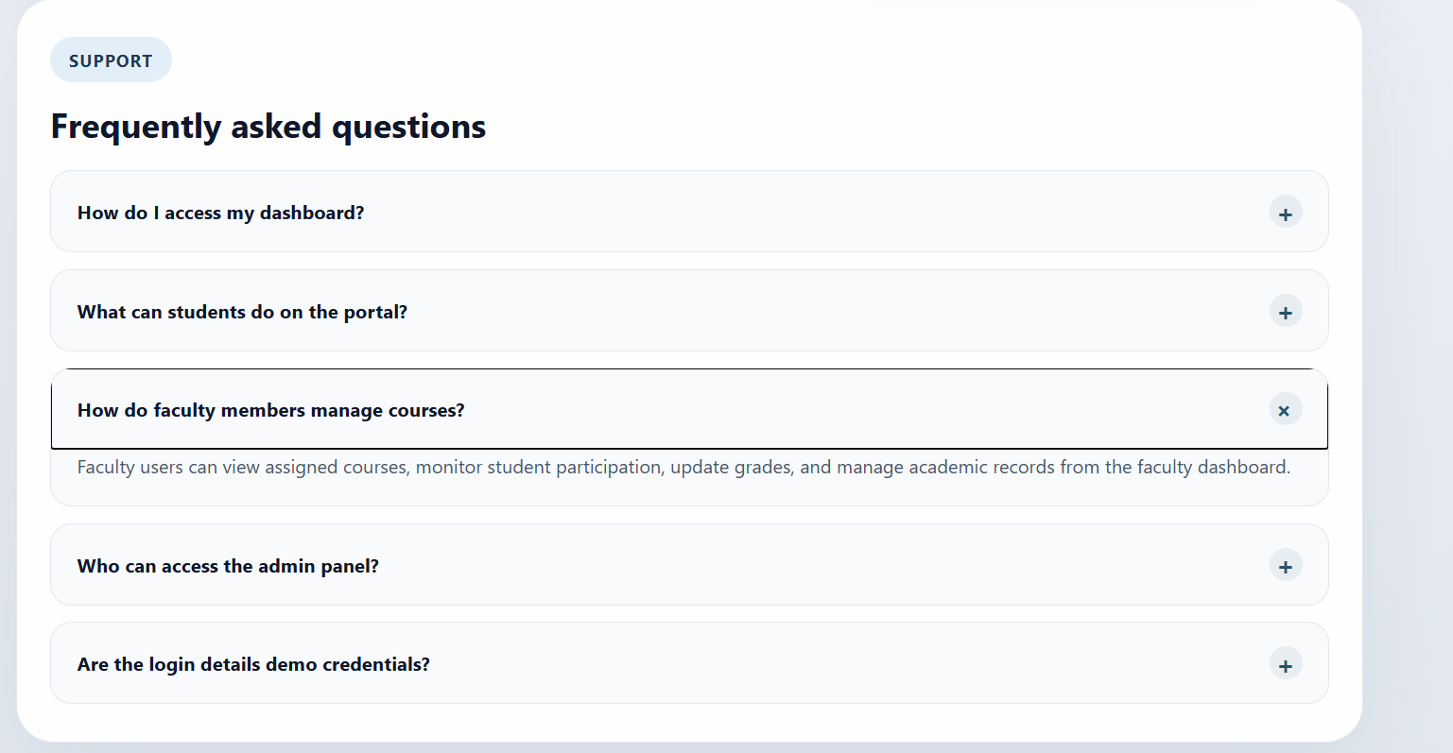
Code of modal popup:
<button class="result-tab" type="button" data-open-result
aria-haspopup="dialog" aria-controls="result-modal-overlay" aria-expanded="false">
Results
</button>

<div id="result-modal-overlay" class="result-modal-overlay" aria-hidden="true">
<div class="result-modal" role="dialog" aria-modal="true"
aria-labelledby="result-title" tabindex="-1">
<button id="close-result" class="result-close" type="button"
aria-label="Close result">&times;</button>

<h2 id="result-title" class="result-title">Student Result</h2>

<div class="result-meta">
<p><strong>Name:</strong> John Doe</p>
<p><strong>Enrollment No:</strong> 202500123</p>
<p><strong>Course:</strong> CSE</p>
<p><strong>Semester:</strong> 3</p>
</div>

<table class="result-table">
<thead>
<tr><th>Subject</th><th>Marks</th><th>Grade</th></tr>
</thead>
<tbody>
<tr><td>Web Development</td><td>88</td><td>A</td></tr>
<tr><td>Database Management</td><td>84</td><td>A</td></tr>
<tr><td>Java Programming</td><td>91</td><td>A+</td></tr>
<tr><td>Operating System</td><td>80</td><td>A</td></tr>
<tr><td>Computer Networks</td><td>86</td><td>A</td></tr>
</tbody>
</table>

<div class="result-summary">
<p><strong>Total:</strong> 429 / 500</p>
<p><strong>Percentage:</strong> 85.8%</p>
<p><strong>CGPA:</strong> 8.9</p>
<p class="result-pass"><strong>Result:</strong> PASS</p>
</div>

<button class="download-result" type="button">Download Result</button>
</div>
</div>
const resultTab = document.querySelector('[data-open-result]');
const resultModalOverlay = document.getElementById('result-modal-overlay');
const closeResultButton = document.getElementById('close-result');

if (resultTab && resultModalOverlay) {
const resultModal = resultModalOverlay.querySelector('.result-modal');

const openResultModal = () => {
resultModalOverlay.classList.add('visible');
resultModalOverlay.setAttribute('aria-hidden', 'false');
resultTab.setAttribute('aria-expanded', 'true');
resultModal.focus();
};

const closeResultModal = () => {
resultModalOverlay.classList.remove('visible');
resultModalOverlay.setAttribute('aria-hidden', 'true');
resultTab.setAttribute('aria-expanded', 'false');
resultTab.focus();
};

resultTab.addEventListener('click', openResultModal);
closeResultButton.addEventListener('click', closeResultModal);

resultModalOverlay.addEventListener('click', event => {
if (event.target === resultModalOverlay) closeResultModal();
});

document.addEventListener('keydown', event => {
if (event.key === 'Escape' && resultModalOverlay.classList.contains('visible')) {
closeResultModal();
}
});
}

Screenshot of modal popup:
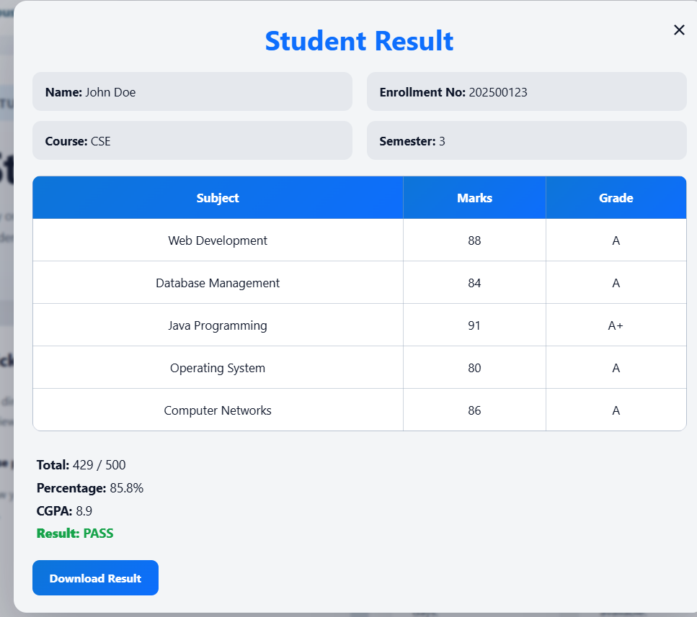
Code of image slider:
.hero-gallery {
display: block;
padding: 36px 42px;
}

.slider-card {
margin-top: 24px;
padding: 24px;
border-radius: 32px;
background: rgba(255, 255, 255, 0.95);
border: 1px solid var(--border);
box-shadow: var(--shadow);
}

.slider-frame {
position: relative;
display: grid;
align-items: center;
}

.slider-track {
position: relative;
min-height: 460px;
overflow: hidden;
border-radius: 24px;
}

.slide {
position: absolute;
inset: 0;
opacity: 0;
transform: translateX(24px);
transition: opacity 0.45s ease, transform 0.45s ease;
}

.slide.active {
opacity: 1;
transform: translateX(0);
}

.slide img {
width: 100%;
height: 460px;
object-fit: cover;
display: block;
}

.slide-caption {
position: absolute;
left: 24px;
right: 24px;
bottom: 24px;
padding: 20px 24px;
border-radius: 18px;
background: rgba(15, 23, 42, 0.72);
color: #ffffff;
backdrop-filter: blur(6px);
}

.slide-caption h2 {
margin: 0 0 8px;
font-size: 1.3rem;
}

.slide-caption p {
margin: 0;
color: rgba(255,255,255,0.9);
}

.slider-control {
position: absolute;
top: 50%;
transform: translateY(-50%);
z-index: 2;
border: none;
width: 46px;
height: 46px;
border-radius: 50%;
background: rgba(255, 255, 255, 0.9);
color: var(--accent);
font-size: 1.2rem;
cursor: pointer;
box-shadow: 0 12px 24px rgba(15, 23, 42, 0.14);
}

.slider-control.prev {
left: 16px;
}

.slider-control.next {
right: 16px;
}

.slider-dots {
display: flex;
justify-content: center;
gap: 10px;
margin-top: 16px;
}

Screenshot of image slider:

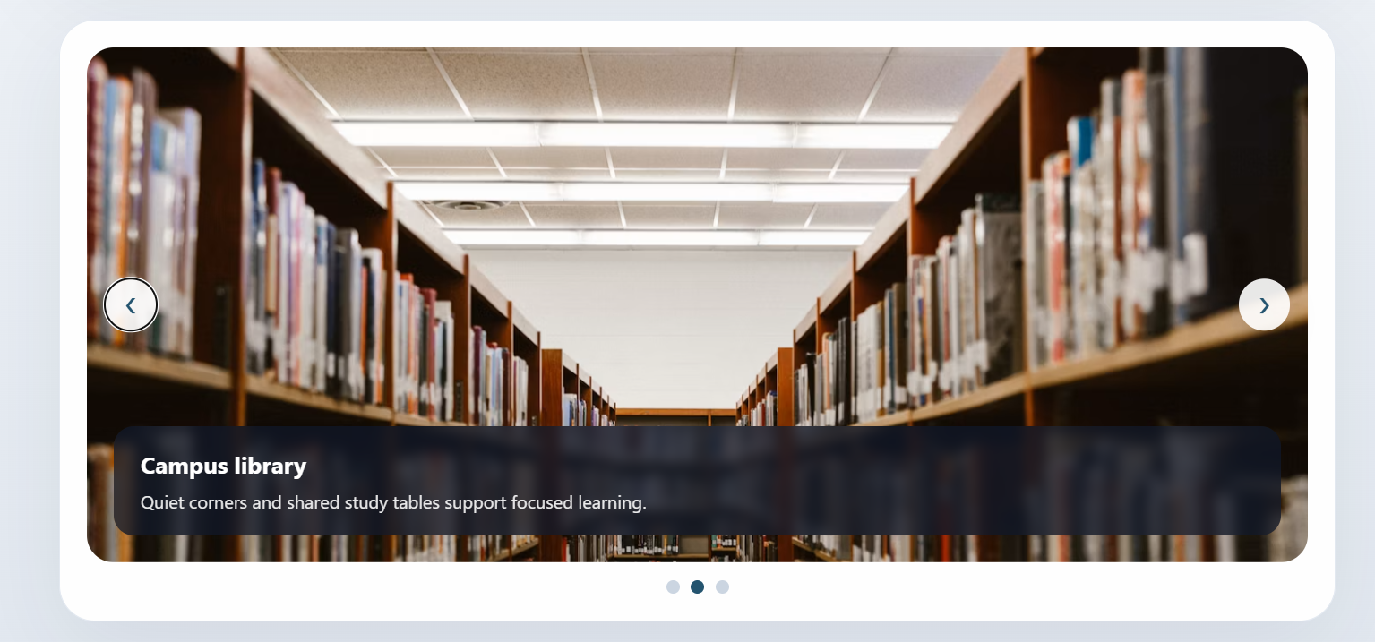
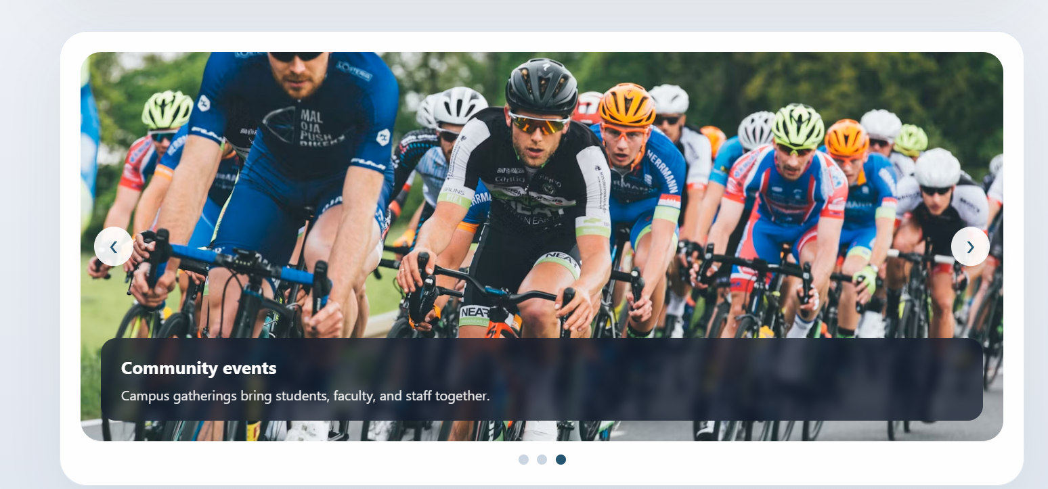

Code of notification banner, hamburger menu, and light/dark theme:
<!DOCTYPE html>
<html lang="en" data-theme="light">
<head>
<meta charset="UTF-8">
<meta name="viewport" content="width=device-width, initial-scale=1.0">
<meta name="color-scheme" content="light dark">
<title>Student Hub | Campus Portal</title>
<style>
:root {
color-scheme: light;
font-family: "Segoe UI", Tahoma, sans-serif;
background: #eef4f2;
color: #18312e;
--page: #eef4f2;
--surface: #ffffff;
--surface-soft: #f5f9f8;
--text: #18312e;
--muted: #536966;
--accent: #08776d;
--accent-strong: #075b54;
--accent-soft: #dff1ed;
--border: #d6e3df;
--notice: #183e3a;
--notice-text: #f4fffc;
--shadow: 0 16px 42px rgba(24, 49, 46, 0.08);
}

html[data-theme="dark"] {
color-scheme: dark;
--page: #142321;
--surface: #1d302d;
--surface-soft: #233936;
--text: #edf7f4;
--muted: #b4c8c3;
--accent: #75d5c5;
--accent-strong: #a0e6d9;
--accent-soft: #294b45;
--border: #38524d;
--notice: #0d1917;
--notice-text: #f4fffc;
--shadow: 0 16px 42px rgba(0, 0, 0, 0.2);
}

* {
box-sizing: border-box;
}

body {
min-height: 100vh;
margin: 0;
background:
radial-gradient(ellipse at 90% 0%, rgba(8, 119, 109, 0.08), transparent 32rem),
var(--page);
color: var(--text);
transition: background-color 0.2s ease, color 0.2s ease;
}

button,
a {
font: inherit;
}

a {
color: inherit;
}

.page-shell {
width: min(1120px, calc(100% - 36px));
margin: 0 auto;
padding: 24px 0 38px;
}

.site-header {
display: flex;
align-items: center;
justify-content: space-between;
gap: 20px;
padding: 16px 20px;
border: 1px solid var(--border);
border-radius: 8px;
background: var(--surface);
box-shadow: var(--shadow);
}

.brand {
color: var(--text);
font-family: Georgia, "Times New Roman", serif;
font-size: 1.4rem;
font-weight: 700;
text-decoration: none;
white-space: nowrap;
}

.menu-toggle {
display: none;
width: 42px;
height: 42px;
padding: 10px;
border: 1px solid var(--border);
border-radius: 6px;
background: var(--surface);
color: var(--text);
cursor: pointer;
}

.menu-toggle span {
display: block;
height: 2px;
margin: 4px 0;
background: currentColor;
}

.site-nav {
display: flex;
align-items: center;
justify-content: flex-end;
flex-wrap: wrap;
gap: 4px;
}

.site-nav a {
padding: 9px 10px;
border-radius: 5px;
color: var(--muted);
font-size: 0.94rem;
text-decoration: none;
}

.site-nav a:hover,
.site-nav a:focus-visible {
background: var(--accent-soft);
color: var(--accent-strong);
outline: none;
}

.theme-btn {
min-height: 38px;
margin-left: 4px;
padding: 7px 10px;
border: 1px solid var(--border);
border-radius: 5px;
background: var(--surface-soft);
color: var(--text);
cursor: pointer;
}

.theme-btn:hover,
.theme-btn:focus-visible,
.menu-toggle:focus-visible,
.notice-close:focus-visible {
outline: 3px solid var(--accent);
outline-offset: 2px;
}

.notification {
display: flex;
align-items: center;
justify-content: space-between;
gap: 20px;
margin-top: 16px;
padding: 14px 18px;
border-radius: 6px;
background: var(--notice);
color: var(--notice-text);
}

.notification p {
margin: 0;
line-height: 1.6;
}

.notice-label {
margin-right: 8px;
color: #a9e6d9;
font-weight: 700;
}

.notice-close {
flex: 0 0 auto;
width: 34px;
height: 34px;
border: 0;
border-radius: 5px;
background: transparent;
color: inherit;
font-size: 1.5rem;
line-height: 1;
cursor: pointer;
}

.hero {
margin-top: 24px;
padding: clamp(28px, 6vw, 64px);
border: 1px solid var(--border);
border-radius: 8px;
background: linear-gradient(120deg, var(--surface), var(--surface-soft));
box-shadow: var(--shadow);
}

.eyebrow {
margin: 0 0 12px;
color: var(--accent-strong);
font-size: 0.8rem;
font-weight: 700;
text-transform: uppercase;
}

.hero h1 {
max-width: 720px;
margin: 0;
font-family: Georgia, "Times New Roman", serif;
font-size: clamp(2.2rem, 5vw, 4rem);
line-height: 1.08;
}

.hero-copy {
max-width: 620px;
margin: 16px 0 0;
color: var(--muted);
font-size: 1.05rem;
line-height: 1.75;
}

.quick-access {
margin-top: 34px;
}

.section-heading {
display: flex;
align-items: end;
justify-content: space-between;
gap: 16px;
margin-bottom: 16px;
}

.section-heading h2 {
margin: 0;
font-family: Georgia, "Times New Roman", serif;
font-size: 1.8rem;
}

.card-grid {
display: grid;
grid-template-columns: repeat(3, minmax(0, 1fr));
gap: 16px;
}

.hub-card {
min-height: 190px;
padding: 22px;
border: 1px solid var(--border);
border-radius: 6px;
background: var(--surface);
box-shadow: var(--shadow);
}

.hub-card h3 {
margin: 0 0 10px;
font-size: 1.15rem;
}

.hub-card p {
min-height: 50px;
margin: 0 0 16px;
color: var(--muted);
line-height: 1.6;
}

.card-link {
display: inline-block;
color: var(--accent-strong);
font-weight: 700;
text-decoration-thickness: 1px;
text-underline-offset: 3px;
}

.page-footer {
margin-top: 36px;
padding-top: 18px;
border-top: 1px solid var(--border);
color: var(--muted);
font-size: 0.9rem;
}

[hidden] {
display: none !important;
}

@media (max-width: 820px) {
.site-header {
flex-wrap: wrap;
}

.menu-toggle {
display: block;
margin-left: auto;
}

.site-nav {
display: none;
width: 100%;
align-items: stretch;
flex-direction: column;
padding-top: 12px;
border-top: 1px solid var(--border);
}

.site-nav.show {
display: flex;
}

.site-nav a,
.theme-btn {
width: 100%;
margin: 0;
text-align: left;
}

.card-grid {
grid-template-columns: 1fr;
}

.hub-card {
min-height: auto;
}

.hub-card p {
min-height: auto;
}
}

@media (prefers-reduced-motion: reduce) {
*,
*::before,
*::after {
scroll-behavior: auto !important;
transition-duration: 0.01ms !important;
}
}
</style>
</head>
<body>
<div class="page-shell">
<header class="site-header">
<a class="brand" href="index.html">Student Hub</a>

<button class="menu-toggle" id="menuToggle" type="button"
aria-label="Open navigation" aria-expanded="false" aria-controls="navbar">
<span></span><span></span><span></span>
</button>

<nav class="site-nav" id="navbar" aria-label="Main navigation">
<a href="index.html">Home</a>
<a href="student-dashboard.html">Student</a>
<a href="academic.html">Academics</a>
<a href="photo-slider.html">Gallery</a>
<a href="support.html">Support</a>
<button id="themeToggle" class="theme-btn" type="button" aria-pressed="false">
<span aria-hidden="true">&#9790;</span> <span>Dark theme</span>
</button>
</nav>
</header>

<aside class="notification" id="notificationBar" aria-label="Campus announcements">
<p><span class="notice-label">Campus updates</span>
Semester results are available. Tech Fest registration is open. New study materials have been uploaded.
</p>
<button class="notice-close" id="closeBtn" type="button" aria-label="Dismiss announcements">&times;</button>
</aside>

<main>
<section class="hero" aria-labelledby="welcome-title">
<p class="eyebrow">Campus Portal</p>
<h1 id="welcome-title">Your campus, in one place.</h1>
<p class="hero-copy">Keep track of academic updates, campus events, and the resources you need throughout the semester.</p>
</section>

<section class="quick-access" aria-labelledby="quick-access-title">
<div class="section-heading">
<h2 id="quick-access-title">Quick access</h2>
</div>
<div class="card-grid">
<article class="hub-card">
<h3>Academic details</h3>
<p>Review course information, attendance, and academic progress.</p>
<a class="card-link" href="academic.html">View academics</a>
</article>
<article class="hub-card">
<h3>Campus gallery</h3>
<p>Browse photos and highlights from campus life.</p>
<a class="card-link" href="photo-slider.html">Open gallery</a>
</article>
<article class="hub-card">
<h3>Student support</h3>
<p>Find help and answers to common campus questions.</p>
<a class="card-link" href="support.html">Get support</a>
</article>
</div>
</section>
</main>

<footer class="page-footer">Campus Portal &copy; 2026</footer>
</div>

<script>
const menuToggle = document.getElementById('menuToggle');
const navbar = document.getElementById('navbar');
const themeToggle = document.getElementById('themeToggle');
const notificationBar = document.getElementById('notificationBar');

function setTheme(theme) {
const isDark = theme === 'dark';
document.documentElement.dataset.theme = isDark ? 'dark' : 'light';
themeToggle.setAttribute('aria-pressed', String(isDark));
themeToggle.innerHTML = isDark
? '<span aria-hidden="true">&#9788;</span> <span>Light theme</span>'
: '<span aria-hidden="true">&#9790;</span> <span>Dark theme</span>';
localStorage.setItem('student-hub-theme', isDark ? 'dark' : 'light');
}

const savedTheme = localStorage.getItem('student-hub-theme');
setTheme(savedTheme === 'dark' ? 'dark' : 'light');

themeToggle.addEventListener('click', () => {
const nextTheme = document.documentElement.dataset.theme === 'dark' ? 'light' : 'dark';
setTheme(nextTheme);
});

menuToggle.addEventListener('click', () => {
const isExpanded = menuToggle.getAttribute('aria-expanded') === 'true';
menuToggle.setAttribute('aria-expanded', String(!isExpanded));
menuToggle.setAttribute('aria-label', isExpanded ? 'Open navigation' : 'Close navigation');
navbar.classList.toggle('show', !isExpanded);
});

navbar.querySelectorAll('a').forEach(link => {
link.addEventListener('click', () => {
navbar.classList.remove('show');
menuToggle.setAttribute('aria-expanded', 'false');
menuToggle.setAttribute('aria-label', 'Open navigation');
});
});

document.getElementById('closeBtn').addEventListener('click', () => {
notificationBar.hidden = true;
});

document.addEventListener('keydown', event => {
if (event.key === 'Escape' && menuToggle.getAttribute('aria-expanded') === 'true') {
navbar.classList.remove('show');
menuToggle.setAttribute('aria-expanded', 'false');
menuToggle.setAttribute('aria-label', 'Open navigation');
menuToggle.focus();
}
});
</script>
</body>
</html>

Screenshot of notification banner :
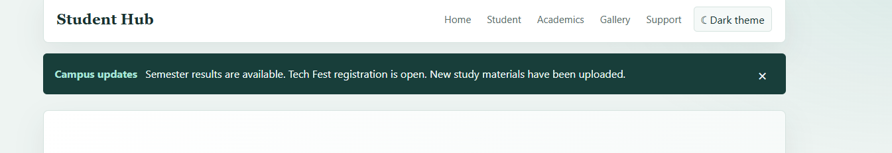
Screenshot of hamburger menu:
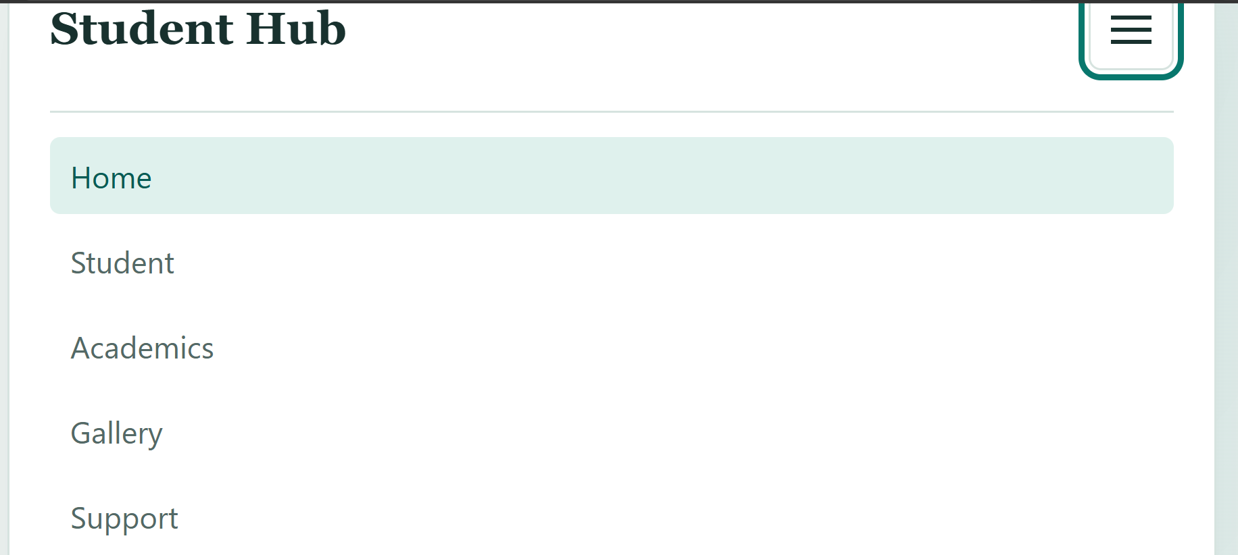
light/dark theme:

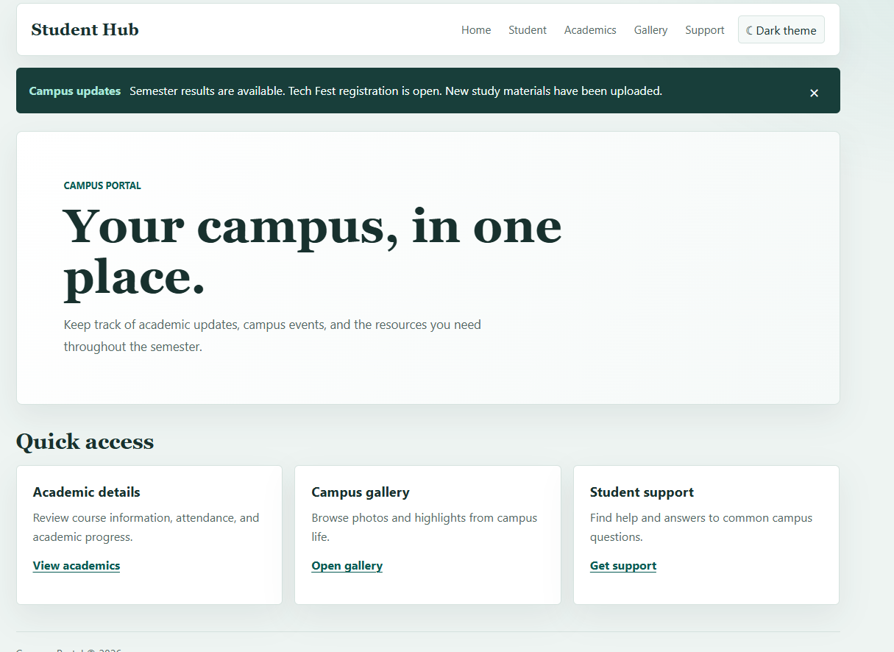
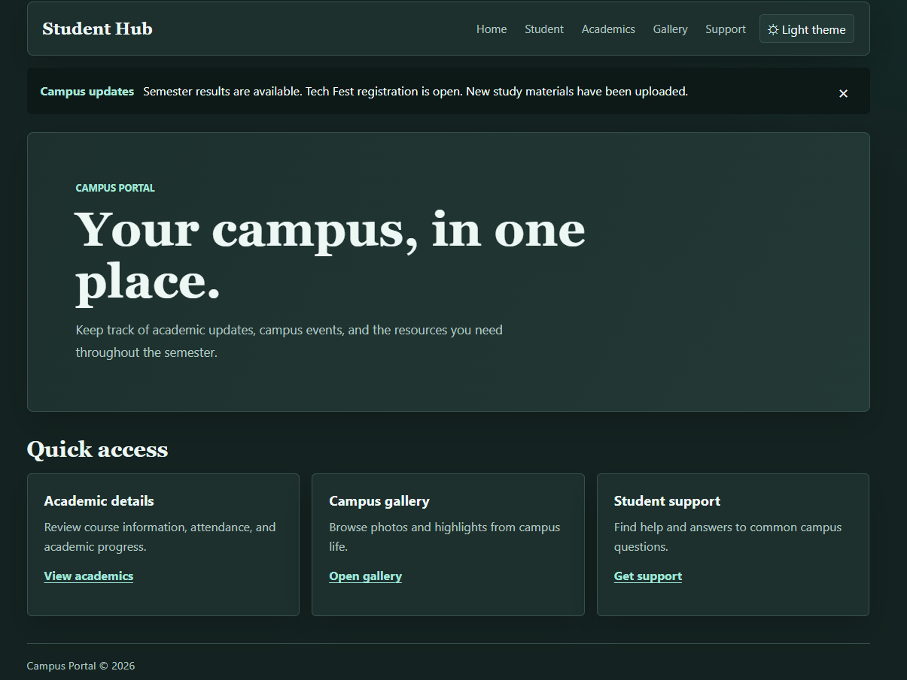
Learning outcome :
Students will design a professional, responsive, and reusable UI layout.

